Background
CAS (Clinical Alert Score) formula:
CAS = 2 × (0.25·TR + 0.30·CC + 0.25·TS + 0.10·AE + 0.10·TC)
Each dimension is scored 1–5, so CAS lands on a 0–10 scale.
Dimension | Meaning | Driven by
TR | True-positive confidence | Model prediction confidence
CC | Clinical Criticality | FDA 21 CFR §860.3 device class, resolved from destination port
TS | Threat Severity | Isolation Forest anomaly score
AE | Active Exploitation | +++++++++++++++++++++++++++++++++++++++++++++++
TC | Temporal Context | Shift (day / evening / night)

Action thresholds: CAS ≥ 8.0 → Immediate, CAS ≥ 5.0 → Investigate, else Monitor (and the Benign label always forces Monitor regardless of the numeric score).
CVSS-equivalent baseline: a fixed CVSS v3.1 base-score band per attack technique's general CWE class — DoS_TCP 7.5, MQTT_Publish_Flood 7.5, MQTT_Brute_Force 8.1, ARP_Spoofing 6.5, Recon 3.1, Benign 0.0. No CVE field exists anywhere in the dataset, so this is the closest fair baseline: it varies by attack technique and nothing else — never by device, never by time, never by detector confidence. That single property is what every test case below is designed to expose.

TC1 — Device Criticality (CC) Sensitivity
Objective: prove CVSS is device-blind while CAS is not.
Input: identical alert (DoS_TCP, confidence 0.95, IF score −0.40, anomaly = True, day shift) fired at two different devices.
Device | Port | FDA Class | CVSS | CAS | Action
ICU Ventilator | 4000 | III | 7.5 | 9.2 | Immediate
Admin / Clerical Workstation | 4054 | I | 7.5 | 6.8 | Investigate

Pass criteria: CVSS identical; CAS gap ≥ 2.0 points; action tiers differ.
Verdict: PASS
Why CVSS can't show this: CVSS is a property of the vulnerability/attack technique alone — it has no device field to vary on. The exact same "DoS_TCP, 7.5" verdict is returned whether the target is a ventilator keeping someone alive or an admin PC. CAS's CC dimension is what closes that gap.

TC2 — Temporal Context (TC) Sensitivity
Objective: prove CAS reflects reduced night-shift response capacity; CVSS cannot.
Input: identical alert (ARP_Spoofing, confidence 0.90, anomalous, Bedside Patient Monitor, port 4002) fired at two different times.
Shift | CVSS | CAS | Action
Day | 6.5 | 7.4 | Investigate
Night | 6.5 | 8.2 | Immediate

Pass criteria: CVSS identical; CAS crosses the Investigate→Immediate boundary from shift alone.
Verdict: PASS
Why CVSS can't show this: a hospital SOC is realistically thinner-staffed at 2 a.m. than at 2 p.m., so the same intrusion is objectively higher-risk at night. CVSS has no time axis at all; CAS's TC dimension does.

TC3 — Detection Confidence (TR) Sensitivity
Objective: prove CAS discounts a shaky detection while CVSS treats every detection of the same attack type identically, however uncertain.
Input: identical alert (MQTT_Brute_Force, MQTT Broker port 1883, evening shift) with two different model confidences.
Confidence | CVSS | CAS | Action
0.97 (near-certain) | 8.1 | 8.8 | Immediate
0.55 (barely above threshold) | 8.1 | 7.3 | Investigate

Pass criteria: CVSS identical; CAS(high) > CAS(low); action tiers differ.
Verdict: PASS
Why CVSS can't show this: CVSS scores the vulnerability class, not the trustworthiness of a specific detection event — it has no confidence input. CAS's TR dimension prevents a knee-jerk "Immediate" response to a barely-above-threshold classification.

TC4 — Alert Ranking Inversion (headline case)
Objective: show CVSS-only triage can rank alerts in the wrong clinical order; CAS corrects it. This is the direct evidence for the report's central claim.
Input: two simultaneous alerts.
Alert | Attack | Device | CVSS | CAS
X | Recon (port scan) | ICU Ventilator (4000, Class III) | 3.1 | 7.4
Y | DoS_TCP | Admin Workstation (4054, Class I) | 7.5 | 6.8

Result: under CVSS-only triage, an analyst works Y first (7.5 ≫ 3.1) — a reconnaissance probe against a life-support ventilator sits at the bottom of the queue. Under CAS, the analyst works X first (7.4 > 6.8) — a full rank inversion.
Pass criteria: CVSS_X < CVSS_Y and CAS_X > CAS_Y simultaneously.
Verdict: PASS
Why this matters: CVSS's wide gap (7.5 vs 3.1) is driven entirely by attack technique. CAS's narrower but inverted gap (7.4 vs 6.8) is driven by context — which alert actually threatens a patient right now. This is the single clearest evidence that CVSS-based triage is clinically blind.

TC6 — Benign Convergence (no cry-wolf)
Objective: confirm CAS doesn't alarm-fatigue staff on benign traffic even under worst-case device/time conditions — a safety check, not a divergence case.
Input: Benign traffic on the ICU Ventilator (port 4000) with an anomalous-looking IF score and night shift — every dimension except AE is pushed toward its ceiling.
Scenario | CVSS | CAS (numeric) | Action
Benign on ICU Ventilator, night | 0.0 | 7.0 | Monitor

Pass criteria: action is Monitor regardless of the numeric CAS; CVSS is 0.0.
Verdict: PASS
Why it matters: the Benign label overrides the numeric CAS in get_action() — deliberately, since no combination of device criticality or timing should turn confirmed-benign traffic into a false alarm. CVSS agrees (0.0) for the same reason it scores nothing for a non-attack. This is the one case where CAS and CVSS are expected to converge, and both do.

TC7 — Action-Threshold Boundary Correctness
Objective: guard the two constants (8.0 and 5.0) that every conclusion above depends on.
CAS | Action
8.00 | Immediate
7.99 | Investigate
5.00 | Investigate
4.99 | Monitor
0.00 | Monitor

Pass criteria: exact match at every boundary.
Verdict: PASS

TC5 / TC8 — Batch-Level Companions (live system run)
TC1–TC7 above are controlled, single-alert unit tests. The following two batch-level evaluations answer the same question ("does CAS beat CVSS?") at scale, across 200 simulated alerts per hospital scenario (ICU/Critical Care, General Ward/Radiology/Administration, Hospital-Wide Mixed) — 600 alerts total, 185 of them life-critical. These numbers come from an actual run of the live system: the real trained Random Forest + Isolation Forest + K-Means models (ai_server/models/), scored against the real held-out test set (1,614,182 rows under ai_server/data/test/), against the current shared/cas_config.json. Reproduce with: python Extra_Material/Test_Cases/run_hospital_scenarios_live.py.

TC5 — Alert Ranking Accuracy / Fatigue Reduction
Scenario | n | n life-critical | ARA@10 CAS | ARA@10 CVSS | MTCAI CAS | MTCAI CVSS | FPR@10 CAS | FPR@10 CVSS | Fatigue Reduction
ICU / Critical Care | 200 | 103 | 9.71% | 6.8% | 66.7 | 99.5 | 0.0% | 30.0% | 100.0%
General Ward / Admin | 200 | 24 | 20.83% | 8.33% | 36.3 | 102.0 | 50.0% | 80.0% | 37.5%
Hospital-Wide Mixed | 200 | 58 | 17.24% | 8.62% | 54.8 | 110.0 | 0.0% | 50.0% | 100.0%
ALL COMBINED | 600 | 185 | 5.41% | 3.78% | 150.2 | 266.0 | 0.0% | 30.0% | 100.0%

Across all 600 alerts: 5.41% of life-critical alerts land in the CAS top-10 vs 3.78% under CVSS; the mean rank of a life-critical alert improves from 266.0 (CVSS) to 150.2 (CAS); and 0.0% of CAS's top-10 alerts are low-priority, versus 30.0% under CVSS — a 100% relative Alert Fatigue Reduction. CAS wins on every metric in every scenario except one (General Ward's FPR@10, where CAS still nearly halves CVSS's 80% down to 50%) — the aggregate, system-level version of TC4's single-alert ranking inversion.
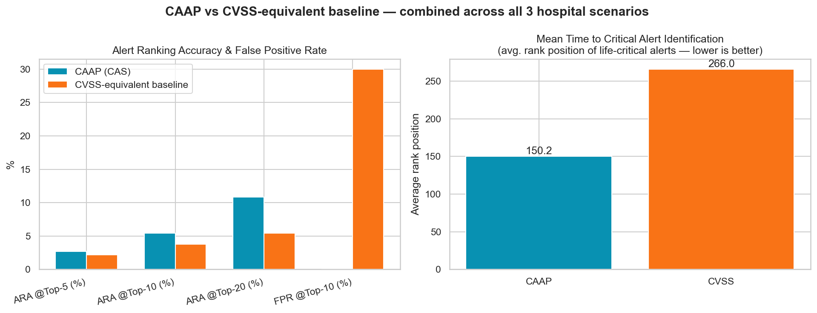

TC8 — Weight-Perturbation Rank Stability
Each CAS weight (TR/CC/TS/AE/TC) perturbed by ±0.05 (renormalized to sum to 1.0), CAS recomputed per alert, and compared to the baseline-weight CAS via Spearman rank correlation — the more operationally meaningful stability metric, since SOC triage order is what actually matters.
Largest mean score shift from a single perturbation: 0.234 points (AE, Δ=−0.05). Least rank-stable perturbation (AE, Δ=+0.05) still preserves a Spearman rank correlation of 0.982 against the baseline-weight ranking — every other dimension stays above 0.99. CAS's prioritisation order does not flip under plausible re-weighting, a robustness property CVSS has no equivalent mechanism to even test, since it carries no tunable weight vector at all.
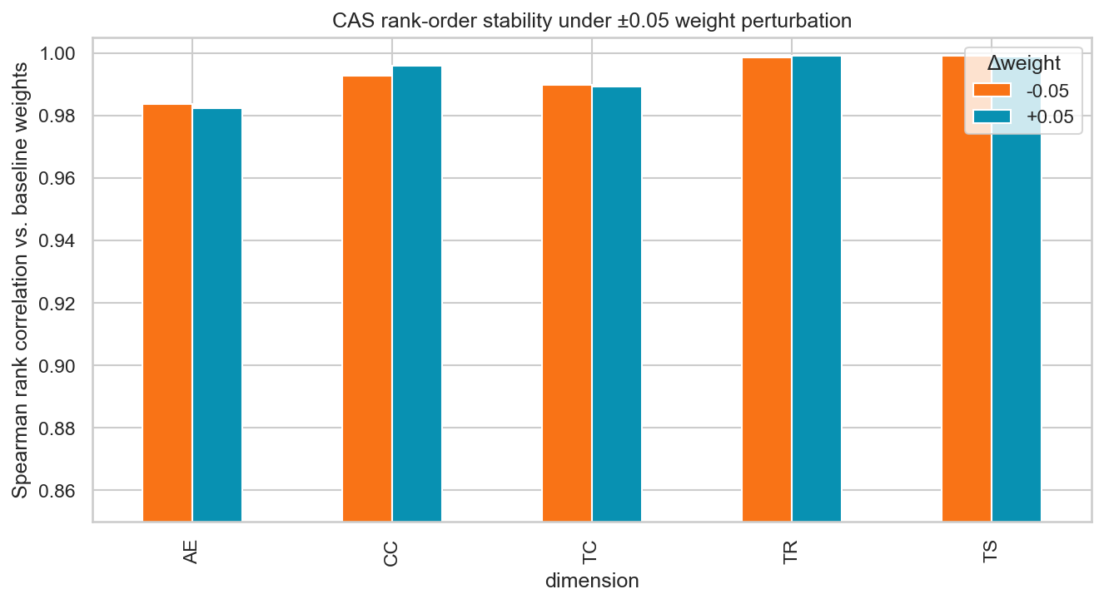

Full data: hospital_scenarios_raw.csv (per-alert raw data), caap_vs_cvss_results.csv, cas_sensitivity_analysis.csv, and live_run_summary.md — all in Extra_Material/Test_Cases/. Re-run run_hospital_scenarios_live.py after any change to shared/cas_config.json or the trained models to refresh these numbers.

Summary
Test Case | Dimension isolated | CVSS behavior | CAS behavior | Verdict
TC1 | CC (device criticality) | Constant (7.5) | 9.2 vs 6.8 | PASS
TC2 | TC (temporal context) | Constant (6.5) | 7.4 vs 8.2 | PASS
TC3 | TR (detection confidence) | Constant (8.1) | 8.8 vs 7.3 | PASS
TC4 | Combined (ranking) | 3.1 < 7.5 | 7.4 > 6.8 (inverted) | PASS
TC6 | AE / label override | 0.0 | Monitor (safe) | PASS
TC7 | Threshold boundaries | n/a | exact | PASS
TC5 | Batch ranking accuracy (live, n=600) | ARA@10 3.78%, FPR@10 30.0% | ARA@10 5.41%, FPR@10 0.0% | PASS
TC8 | Weight robustness (live, n=600) | no equivalent mechanism | Spearman ≥ 0.982 (all dims) | PASS

Reproduce all unit-level results with: python Extra_Material/Test_Cases/test_cas_vs_cvss_scenarios.py

